**Energy Trace**

EnergyTrace™ technology for MSP430 and MSP432 microcontrollers is an energy-based code analysis tool that measures and displays the application’s energy profile and helps to optimize it for ultra-low-power consumption.

EnergyTrace measurements exported via a USB bulk endpoint.

Electrical specifications:

* **Accuracy**: ± 2% ± 500nA, **Condition**: I < 25mA, VBUS = 5V constant during and after calibration
* **Accuracy**: ± 5% ± 500nA **Condition**: I > 25mA & I < 75mA, VBUS = 5V constant during and after calibration
* **Maximum** **current**: 100mA
* Fixed voltage for energy and power calculations: 3.3V

Exemplu blink LED

|  |  |  |
| --- | --- | --- |
| **Test 1** | **Test 2** | **Test 3** |
|  |  |  |

|  |  |
| --- | --- |
| Test 1 |  |
| Test 2 |  |
| Test 3 |  |

|  |  |
| --- | --- |
| Test 1 |  |
| Test 2 |  |
| Test 3 |  |

Deep Sleep Energy Consumption for Blink:

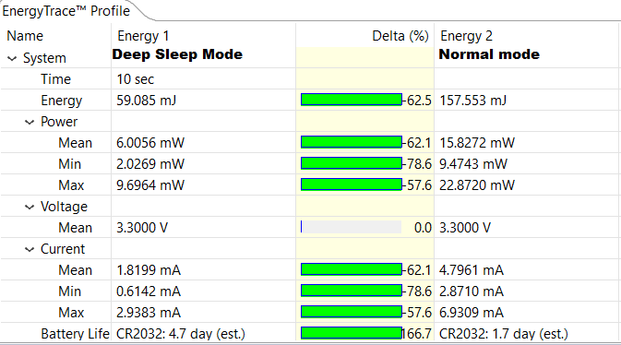

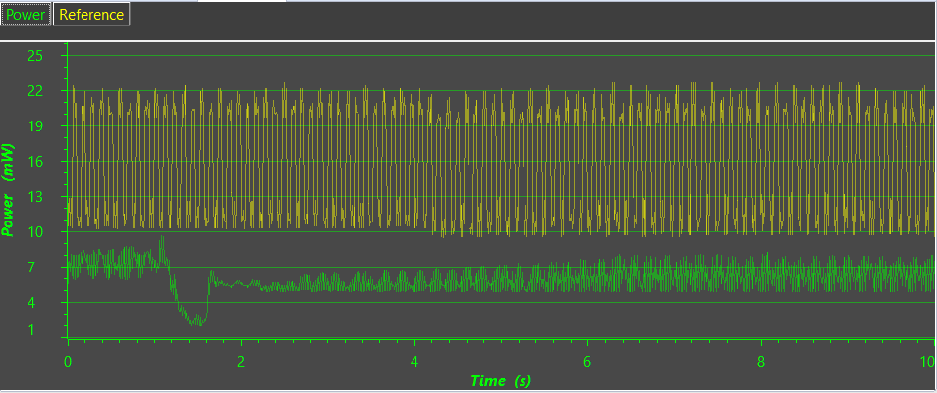

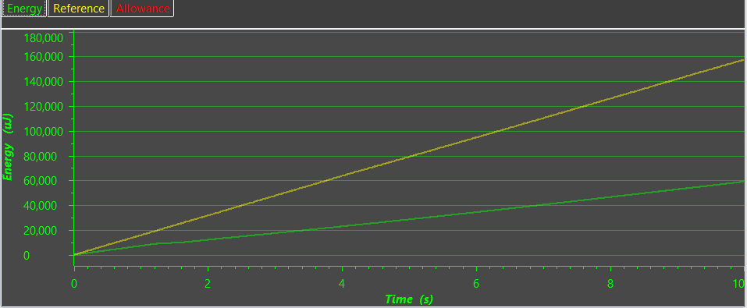

Sleep Modes Test for UART communication:

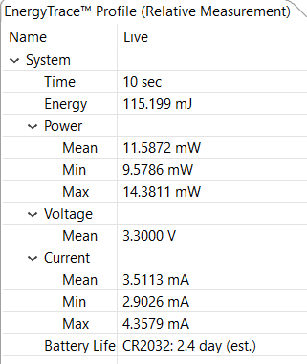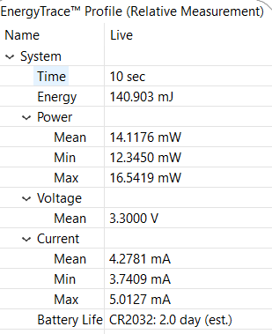

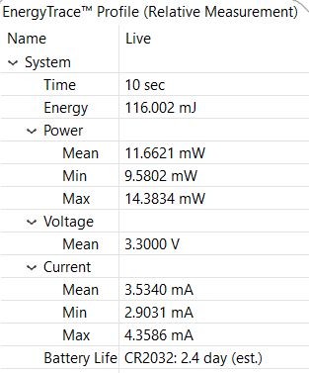

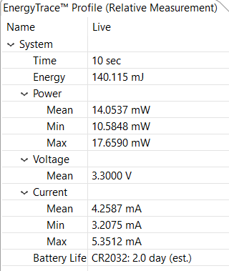

In primul caz este comunicarea prin UART in modul normal. In al 2-lea caz este comunicarea prin UART in modul LPM0(o imbunatatire seminificativa ca mod Low-Power, dar nu mai iasa din Deep-Sleep). Al 3-lea caz este comunicarea prin UART in modul LPM3( de asemenea o imbunatatire seminificativa ca mod Low-Power, dar nu mai iasa din Deep-Sleep). Ultimul caz este LPM4 care este aproximativ acelasi cu modul normal de functionare fara deep-sleep.

Bibliografie: <http://processors.wiki.ti.com/index.php/Energy_Trace_for_MSP432>

<http://processors.wiki.ti.com/index.php/GSG:Debugging_projects_v5#Creating_a_Target_Configuration_File>

<https://e2e.ti.com/support/microcontrollers/msp430/f/166/t/507007>

Code examples: <http://www.ti.com/general/docs/lit/getliterature.tsp?baseLiteratureNumber=slac698&fileType=zip>